Testing Stages
1.Creating the layout and structure of the information about the paper
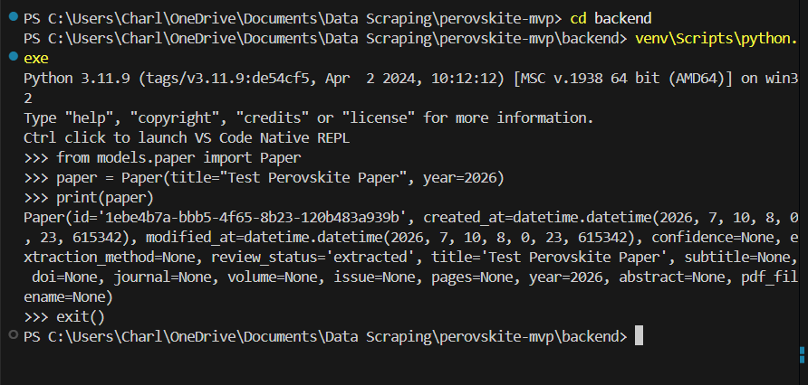

2.Creating the layout of the evidence for each bit of information
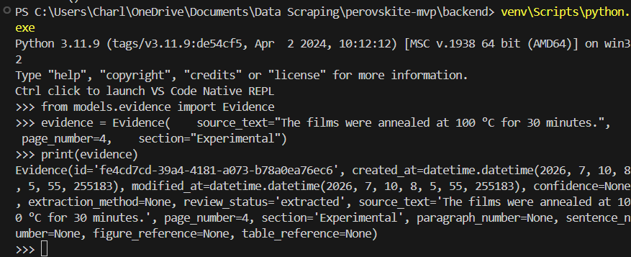

3.Creating the layout of each bit of numerical information
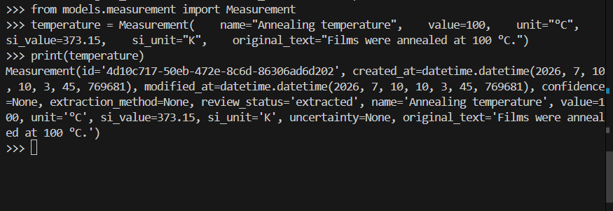

4.Creating the layout for the material identifier
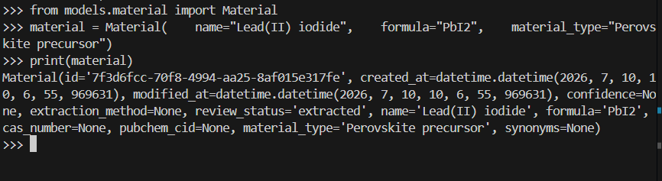

5.Creating the device/stack architecture and layers
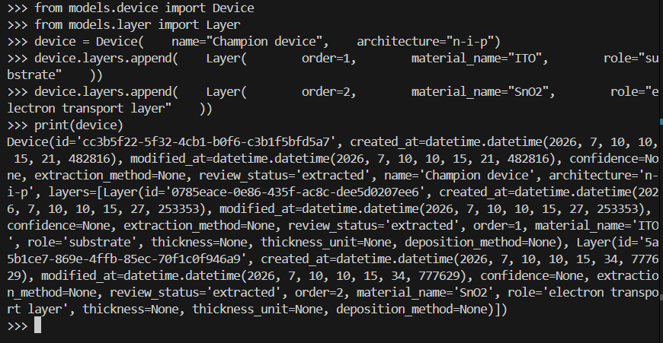

6.Creating the ability to have separate experiments that are linked – useful multiple experiments or methods in one paper
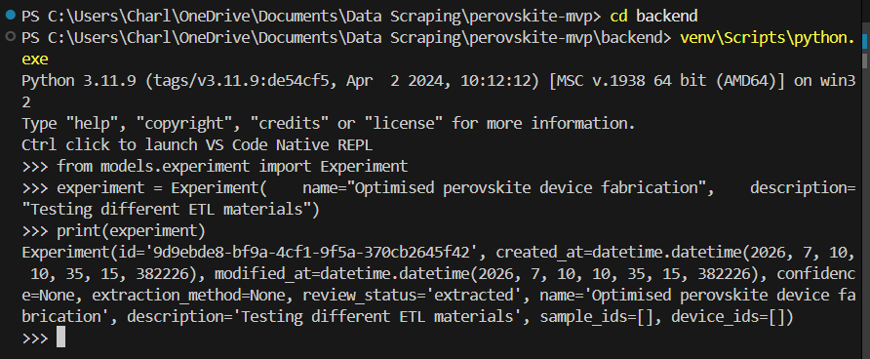

7.Creating a sample
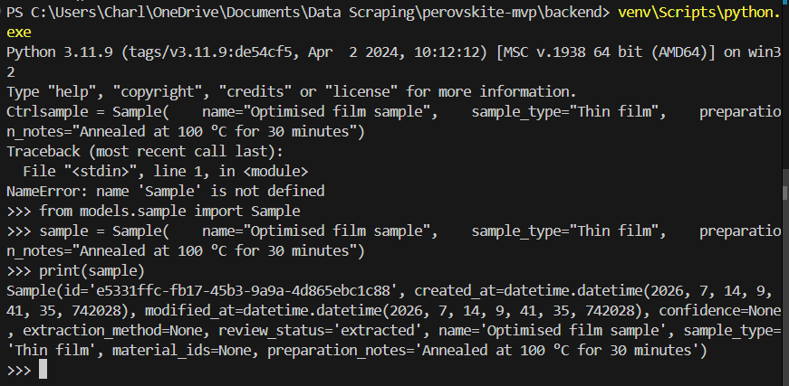

8.Testing all the files in one go
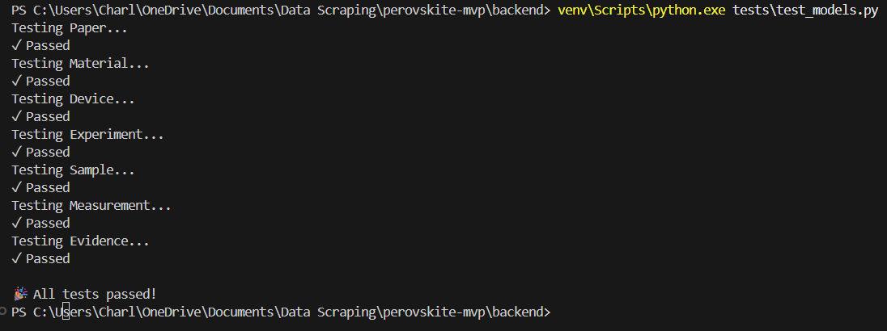

9.Creating the PDF parser tester
